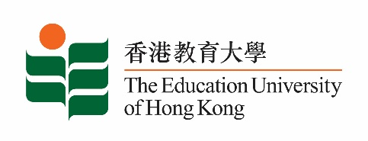
致： 傳媒機構採訪主任 (共 2頁) 5 November 2021
To : News Editors (total: 2 pages)

香港教育大學2021年11月8日至21日可供採訪之活動一覽
The Education University of Hong Kong (EdUHK) Events Calendar for 8 to 21 November 2021
本校誠邀 貴機構派員採訪下列活動。傳媒查詢，請聯絡教大傳訊處（電話：2948 6050）。
You are cordially invited to cover the events below. For media enquiries, please contact the Communications Office at 2948 6050.

因應2019冠狀病毒疫情，以下活動或有人數限制，傳媒請預先向主辦部門登記。
In light of the COVID-19 pandemic, there may be restrictions on the number of participants for the following event(s). Please contact the respective organiser(s) / department(s) for prior registration.

- 教大大埔校園 （新界大埔露屏路十號） / EdUHK Tai Po Campus (10 Lo Ping Road, Tai Po, New Territories)

日期  Date | 時間  Time | 活動  Event | 地點  Venue | 主辦部門及公眾查詢  Organiser &  Public Enquiry | 備註  Remarks
2021-11-13 | 2:30 pm –  4:30 pm | 2021年文學月會 / 香港文學專題講座︰「妙筆呈錦繡──香港粵劇劇本共賞」系列：優秀劇本的特徵：兼論粵劇《胡不歸》與戲劇教育  Monthly Literary Talk 2021 / Subject Talk on Hong Kong Literature: "Appreciating Cantonese Opera: Scripts by Hong Kong Playwrights" Series: The Characteristics of Outstanding Libretti of Cantonese Opera: Application in Theatre Education  講者 / Speaker:  何文匯教授  Professor Ho Man-wui, Richard  梁寶華教授  Professor Leung Bo-wah | 香港中央圖書館  （地下演講廳）  Hong Kong Central Library  (Lecture Theatre, G/F) | 合辦 / Co-Organiser:  康樂及文化事務署香港公共圖書館與教大粵劇傳承研究中心  Hong Kong Public Libraries, Leisure and Cultural Services Department and Research Centre for Transmission of Cantonese Opera, EdUHK  查詢 / Enquiries:  王先生 Mr Wong  電話 / Tel :  2948 7856 | 免費入場，名額有限，先到先得。  Seats are limited. Free admission on a first come, first served basis.  詳情 / Details:  https://www.eduhk.hk/rctco/ch/news.php

